## Lab 8-1: Flow Networks

1. Apply the shortest augmenting path algorithm to find a maximum flow and a minimum cut in the following networks. Show the state of the network after each augmentation of the graph. You may need more or less networks for Edmunds-Karp to run to completion.

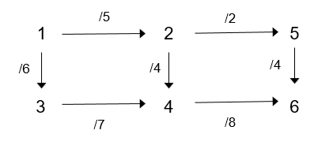







1. Use the **existing flow below** as a starting point for Edmunds-Karp. That is, run the algorithm starting with the residual graph implied by the given flow in the graph below.

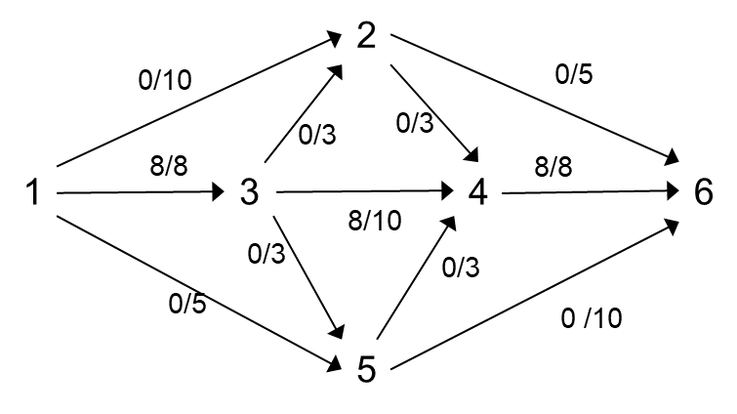

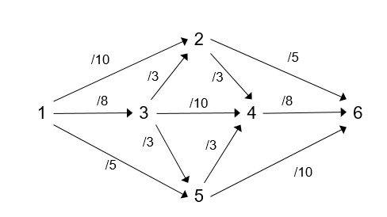





### Let G=(V,E,U) be a flow network and let f = { $x_{i,j}$} be maximum flow on on G. An edge in G is called a bottleneck edge if increasing its capacity results in an increase in the maximum flow.

1. In the following example the edge (4,3) is a bottleneck edge since increasing its capacity by 1 allows the maximum flow to increase by 1. What is the augmenting path the proves this?

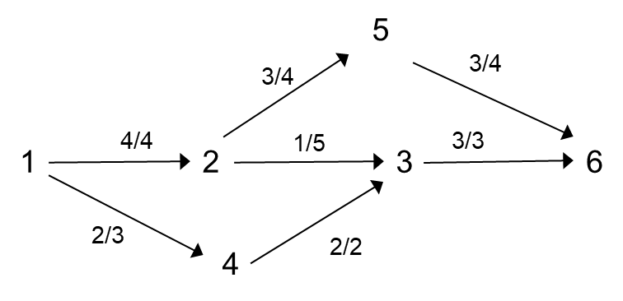If I increase the capacity of edge (4,3) by 1 to now 2 we get an augmenting path of 1, 4, 3, 2, 5, 6. Then, when we augment the flow edge (4,3) is full and now we cannot find another augmenting path. Therefore, our current flow value is the max, which is 7. So, increasing capacity of a bottleneck edge by 1 also increased the max flow by 1.

1. Give a simple example of a flow network with at most 4 edges with no bottleneck edges.

2/2

2/2

2/2

2/2

1 2 3 4 5

1. Give a simple example of a flow network with at most 4 edges that has a single bottleneck edge.

2/2

2/3

2/3

2/3

1 2 3 4 5

1. Give a simple example of a flow network with at most 4 edges that has a two bottleneck edges.

1/1

1/2

1/1

1/2

1 2 3 4

### Explain how a maximum flow problem for a network with several sources and sinks can be transformed into an equivalent problem maximum flow problem with a single source and a single sink that will give the correct answer to the original problem. Draw a picture of your solution and clearly define any vertices and edges (along with their capacities) that are added to the original flow network.

To create an equivalent max flow problem with only a single source and sink, you can add a single source that has edges connected to all of the sources from the original graph and give the edges from our new source to the original sources an infinite capacity. Then, we can do the same for the sinks, where all the original sinks now have edges of infinite capacity going to a single sink. Now, we have an equivalent max flow problem. For example, …

S1

T1

S2

T2

S3

S1

T1

S` S2  T`

T2

S3

### Suppose that in addition to the usual constraints a flow network has capacity constraints on the flow that can go through each intermediate vertex. Explain how a maximum flow problem for such a network can be transformed into an equivalent (will give an answer to the original problem) maximum flow problem. Draw a picture of your solution and clearly define any vertices and edges (along with their capacities) that are added to the original flow network

We can achieve this by splitting each intermediate vertex with capacity constraints into two vertices and connecting these vertices by one edge with capacity of the original intermediate vertex. Make all incoming edges go to the first vertex of the spilt and make all outgoing edges come out of the second vertex of the spilt. For example, if we can a vertex…

cv

V

cv

V` V``